**Quick Guideline**

**Step 1: Preparing**

Prepare a computer, Meta Quest 2, a Facebook account, iPhone, and a cord to connect your Quest to your computer. You may have to change your cord according to the port type of your computer.

On your iPhone: Download the APP – Oculus.

On your computer: You can download the NYUSPS.apk file to start virtual reality journey by clicking this link.

<https://github.com/YuquanDai/Virtual-Reality-Journey>

**Step 2: Download SIDEQUEST to your computer**

To upload the apk. files to your VR headset, you have to use an application on your computer called SIDEQUEST. Click the link below and choose the appropriate version to download. If your computer has Windows system, choose the first version under Advanced Installer (LTS). If you have a MAC, choose the second version under Advanced Installer (LTS).

<https://sidequestvr.com/download>

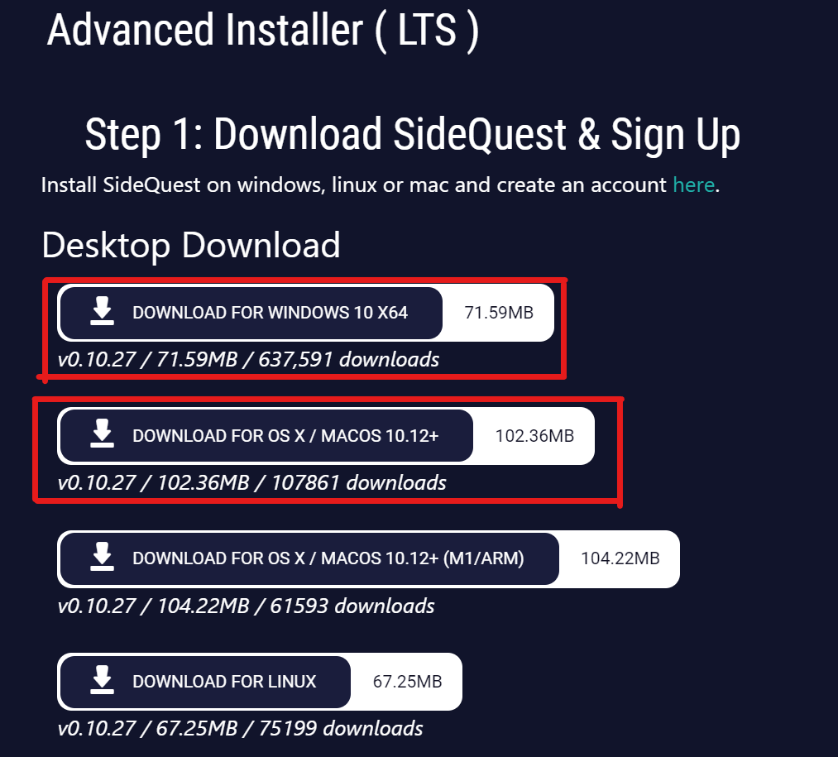

**Step 3: First Time Setup**

There’s a couple of initial setup steps you’ll need to complete first in order to use SideQuest with your headset.

**Register as a developer on the Oculus account associated with your Quest**

Click the link below. Enter a new organization name and tick the ‘I understand’ box to agree to the Oculus Terms of Service. You can name your organization whatever you want.

<https://developer.oculus.com/manage/organizations/create/>

**Enable Developer Mode on your Quest**

Open the Oculus app on your phone, with your Quest turned on so it can connect to the app, and then:

1. Tap ‘Manu’ in the bottom right
2. Tap the ‘Devices’ button
3. Connect your Quest headset. Make sure your Quest is turned on, and your phone has Bluetooth and WiFi turned on as well.
4. Tap on ‘Developer Mode’
5. Flick the switch to On instead of Off
6. Fully reboot your Quest – hold down the power button on the side and select ‘Power Off’ or ‘Restart’.

After rebooting, your Quest should be in Developer Mode.

**Step 4: Connect Quest to your computer, and sideload the .apk file you downloaded in step 1.**

Open the SideQuest app on your computer. Connect your Quest to your computer with a cable. Click ‘Allow’ on your headset, and make sure SideQuest is connected to your VR headset. (The top-left dot will be green)

To sideload Quest APK files, click on the ‘install APK file from folder on computer’ button. (See the highlighted icon below)

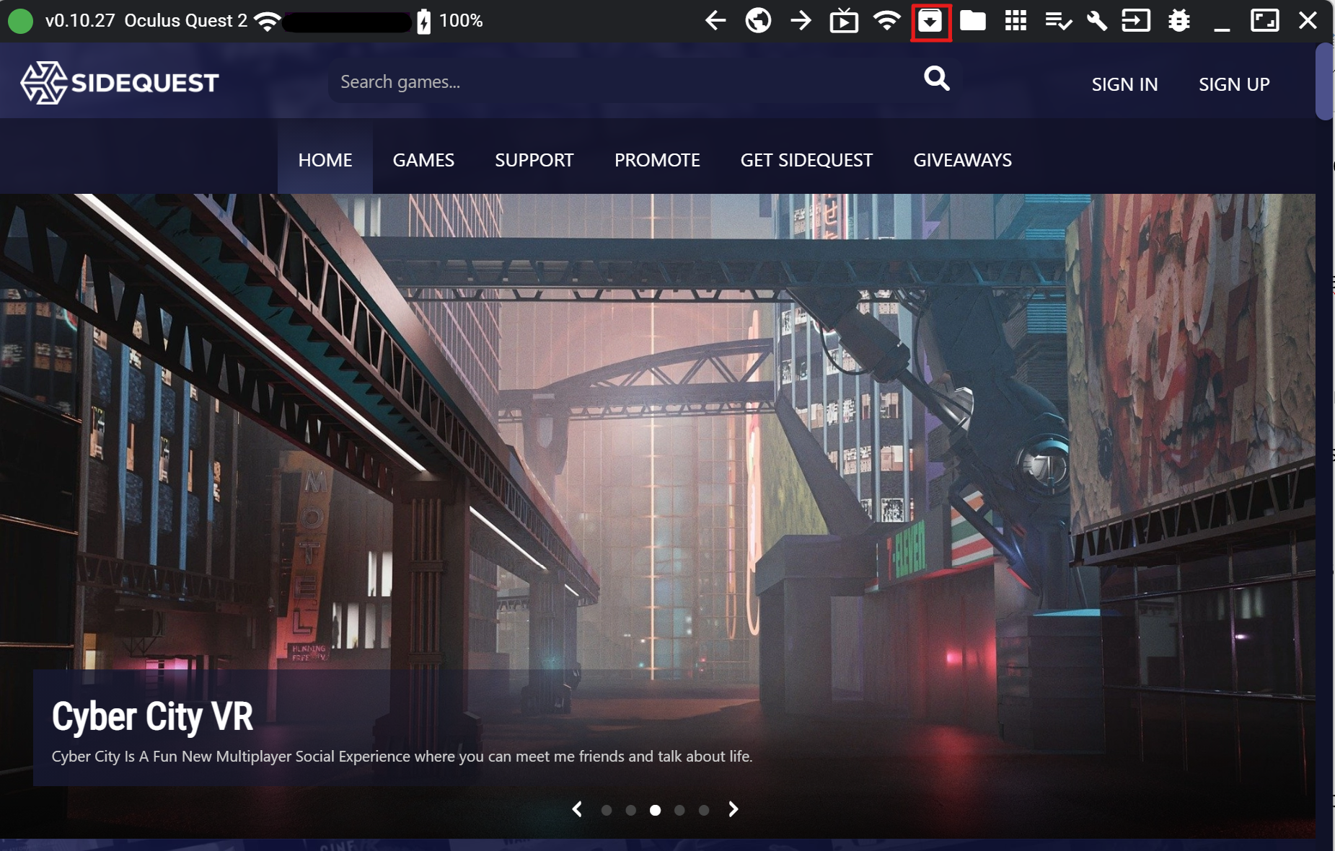

This will allow you to locate and select the APK file, and SideQuest will then install it onto your Quest. You can check if the installation is successful in the ‘Tasks’ tab.

**Step 5: Enjoy your virtual reality journey**

After the successful install, put on your headset. Click App Library, you can find the file under the category of unknown sources. Choose the file you uploaded and start an amazing virtual reality journey!

**Step 6: Share the scene with others**

You can share the screen of your headset to your computer or iPhone. To share to your iPhone, please open Oculus app and click Casting button. After connecting your headset, click Start button to start casting on your iPhone.

To cast on your computer, please put on your Meta Quest 2 headset. Click sharing – cast. Then choose Computer, click the Next button. Put off your headset and turn on your computer, make sure your computer is on the same WiFi network as your headset. Open the link <https://www.oculus.com/casting> in a supported web browser such as Google Chrome. Then the browser will start casting automatically.